# Prerequisites

* .Net Core Run Time/ Hosting 3.0 should be installed on the server. This can be downloaded from the following link <https://dotnet.microsoft.com/download/thank-you/dotnet-runtime-3.0.0-windows-hosting-bundle-installer>
* App pool created for hosting the application should have .net CLR versionas “NoManged Code”. Check the following screen shot

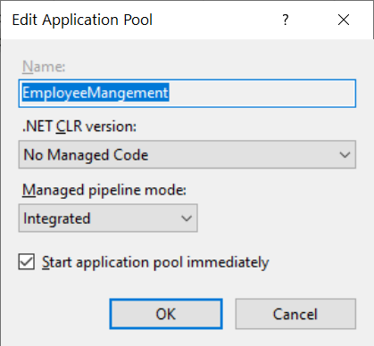

# Build and Publish

1. Nuget Restore
2. Rebuild Solution
3. Run Unit Tests
4. If all the tests are passing. You can publish from VS with the correct configuration. Settings.json file need to transformed based on the configuration.
5. The output can be copied to IIS website.
6. Make sure the connection string is pointed at the correct database.
7. Recycle the App pool

All the above steps can be scripted out as steps in a build script.